**Audit Report**



**Team Members: Team05**

Bhoomibahen Raval

Ramandipsingh Dhillon

Sukhdeep Kaur

Harpreet Kaur

Table of Contents

Abstract 2

Goals of project 2

Project Mission 2

Importance of project: 2

Features of Project 2

Project Requirement……………………………………………………………………………………………………………………………….3

Schedule of project……………………………………………………………………………………………………………………………….…4

Responsibilities of Team Members 5

Project work done by teammembers………………………………………………………………………………………………..…6

Alpha Release Interation 1………………………………………………………………………. .7

User story cards of alpha release………………………………………………………………….8

Landing Page………………………………………………………………………………….9

Our breed page …………………………………………………….………………………….11

Dog’s available Page………………………………………………………………………......15

Adoption……………………………………………………………………………………....18

Phpmyadmin(Database)…………………………………………………………………………24

Client signed agreement ……………..………………………………………………………….29

Burn-down/velocity Graph………………………………………………………………………32

Configuration Management……………………………………………………………………..32

Prototype…………………………………………………………………………………………32

Beta Release Interation-2………………………………………………………………………33

**Abstract**

This Report is demonstrate the development and Tasks of team members. And also provide information about future project. The title of this project is” Bull Terrier rescue”.

# Goals of Project

## Project Mission

* The purpose of this website is, rescuing bull terriers and helps them to stay in appropriate homes for forever. So, if People want to help them, they can go through by our website.
* In addition to, we arrange programs such as Adoption program; foster home program, volunteer program, Surrender program for great bull terrier experience.
* Bull terrier rescue website is Provide information about upcoming events programs.

# Features

* Give information about dogs available for adoption.
* Provide information about upcoming event.
* Brief description about dogs.
* Provide information about dog’s Temperament, breeds, physical aspects, physical problems.
* Adoption form to adopt dogs.
* This website would be very easy to operate. Therefore, any user who is beginner to internet can easily access it.

**Project Requirements**

* **Colors and Style:**

Style, colors, heading and layout must be effective and attractive.

* **Load time of website:**

Load time is important for website, because some website takes so much time to page load. And Because of that, sometime user just leave that website and move to another website.

* **Proper Format of fonts:**

There should be a proper font format such as same size, line spacing etc.

* **Proper links:**

There should be a proper link so user can navigate it easily.

Project Development

* Index.php
* Ourbreed.html
* Adoption.html
* Dogsavailable.html

**Schedule of Project**

|  |  |  |
| --- | --- | --- |
| No | Project Work | Day |
| 1 | Title | 2 Day |
| 2 | Features | 3 Day |
| 3 | Strength and weakness | 2 Days |
| 4 | Home page Layout | 3 Days |
| 5 | Our breed Page Layout | 3 Days |
| 6 | Dogs Available | 3 Days |
| 7 | Adoption | 3 Days |
| 8 | Admin Dashboard | 4 Days |
| 9 | Admin Add/Edit Dogs. | 2 Days |

# 

# Responsibilities of Team Members

|  |  |  |
| --- | --- | --- |
| Team Member Name | Weaknesses | Strengths |
| Bhoomibahen Raval | * Code Testing | * Color selection * Project contents * Designing Layout * Collect information |
| Ramandeepsingh Dhillon | * Gathering Information | * Select Images, Pictures * Goal * Features |
| Sukhdeep Kaur | * Features | * Content * Project development * Layout |
| Harpreet Kaur | * Layout | * Formatting * Font * Color combination |

**Project work done by team members**

|  |  |
| --- | --- |
| **Tasks of each team members** | |
| **TASKS** | **Name of Team members** |
| Project Title Finalize | Team |
| Project Features | Team |
| Coding, Database, Layout, Design, Audit Report, phpmyadmin,ourbreed.html, Gathering Information,Presentation,Responsive.css | BhoomiRaval |
| Coding, Database, Layout, Design, phpmyadmin,Admin dashboard  Gathering Information, Login | Ramandeepsingh Dhillon |
| Database, coding, layout,  Design, Index.php,  Gathering Information,main.css | Sukhdeep Kaur |
| Layout, coding, Database, Design ,Dogsavailable.html,  Gathering Information,style.css | Harpreet Kaur |

**Alpha Release (Interation-1)**

This project is divided in to two parts Alpha Release and Beta Release. So, first developer need to signed agreement from client with the explanation of alpha release. And after signed agreement from client developer can go threw for next step. The features of Alpha Release for this project is as below:

**Alpha Release**

In Alpha release we have done following features:

* Landing Page
* Ourbreed page
* Dogsavailable page
* Admin dashboard
* Hosting and Domail
* Database

**User Story Cards of Alpha Release**

**Title:** Landing Page(Home page)

**Description:**

**As a …** Visitor

**I need …** Home(landing Page)

**So that …** I can find all menu options+website description (Mission)

**Priority: 10 Time estimate: 2**

**Priority: Time estimate:**

**Title:** Dogs Available

**Description:**

**As a …** visitor

**I need …** page,pictures,details of dogs

**So that …** I can read description of dogs and I can find dogs for adoption

**Priority: 10 Time estimate:3**

**Title: Adoption**

**Description:**

**As a … Visitor**

**I need …** form to fill out with details

**So that …** I can contact admin and express interest to adopt a dog

**Priority: 10 Time estimate: 4**

**Title: Our Breed**

**Description:**

**As a …** visitor

**I need …** to know about dog breeds before adoption

**So that …** I can know about dog their personality,temperament,relationship with other animal,etc

**Priority: 10 Time estimate: 3**

**Title:** Admin Dashboard

**Description:**

**As a …** site admin

**I need …** login form

**So that …** I can access admin dashboard with admin options

**Priority: 10 Time estimate: 4**

**Title:** Admin Add/Edit Dogs

**Description:**

**As a …**site admin

**I need …** forms in dashboard

**So that** … I can add and edit dogs available for adoption

**Priority:10 Time estimate: 3**

1. **Landing Page (Home Page)**

* Landing page/Home page is main page of website. Landing page is necessary for user, because user can find everything about website on Landing Page.
* In our project, Landing Page directly support Adoption page, our breed page, Admin dashboard.
* Landing Page help to increase more conversation. As well as it help to prevent paid campaigns.
* It helps to improve brand name of business or website.

**Screenshots of Landing page:**

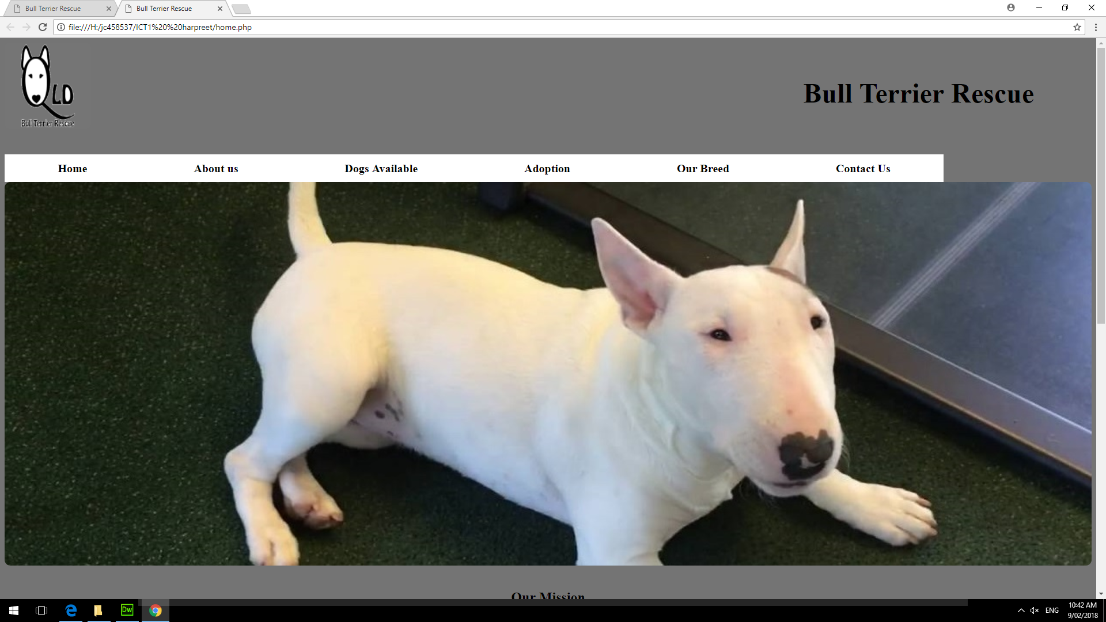

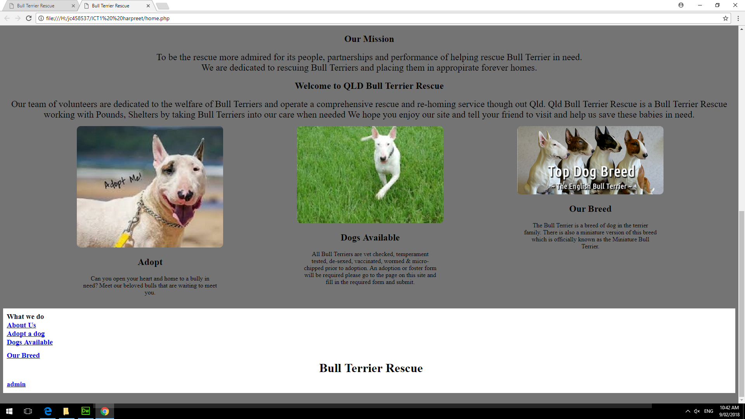

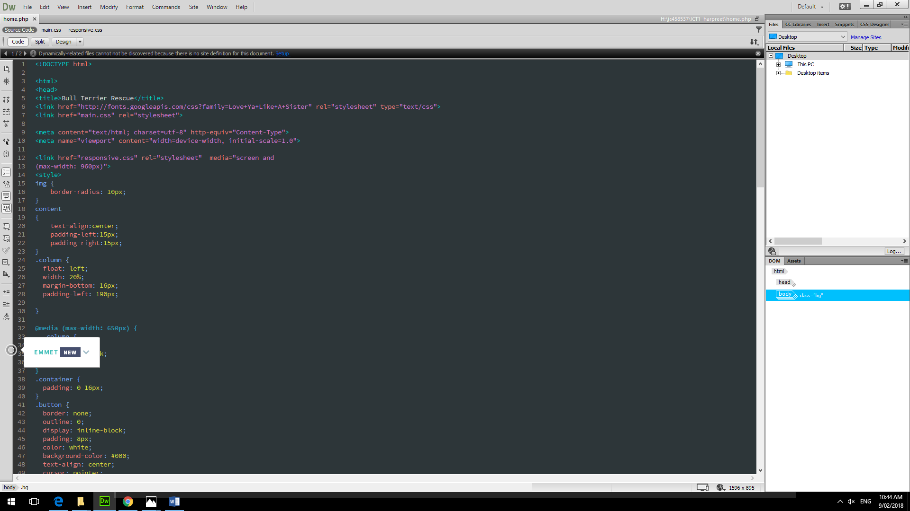

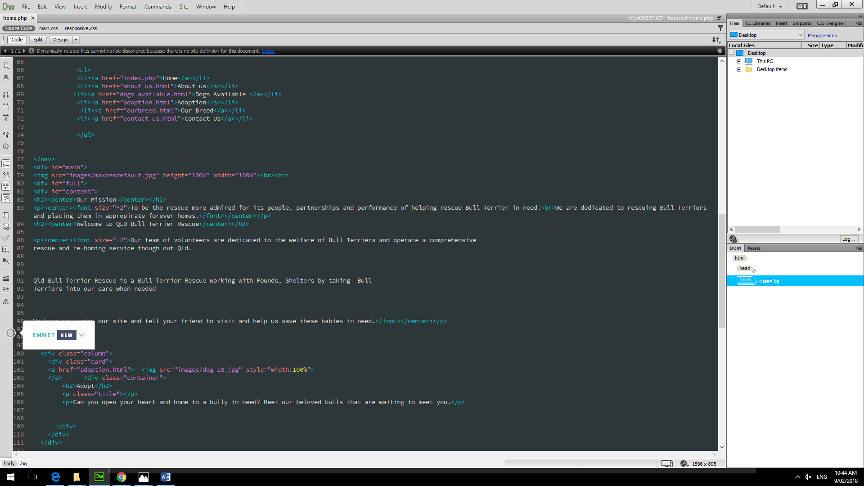

1. **Our breed page**

* Client need our breed page for this project.
* Because it is most important for user to check and research about dog breed before adoption. And every user, who wants to adopt dog, they first do some research about dog before make final decision.
* Our breed page is important, because it contains information about bull terrier dog breeds, and also gives information about their Temperament, Relationship with other dog, Neutering, Physical Aspects, Physical problems etc.
* So, it would be becomes easy for user to do research, and help them to take right decision.

**Screenshots of Our breed page:**

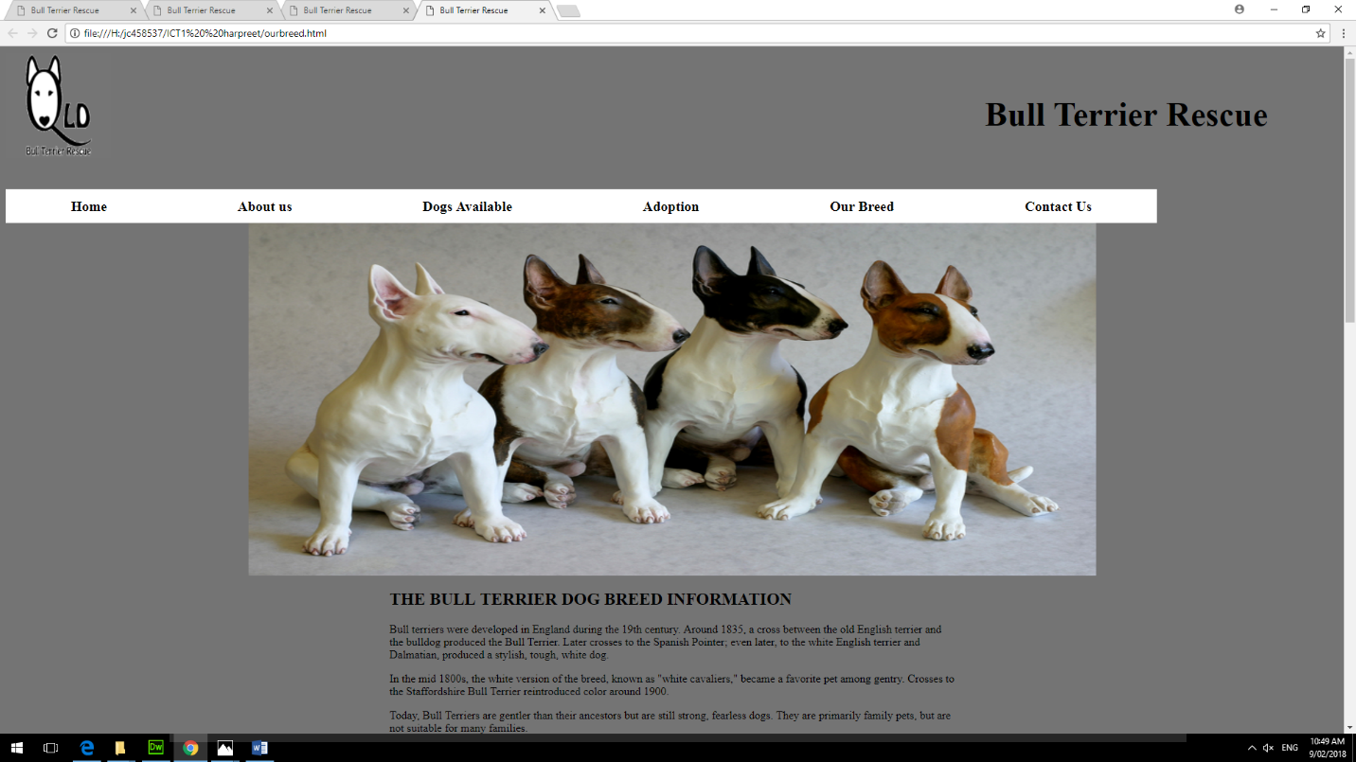

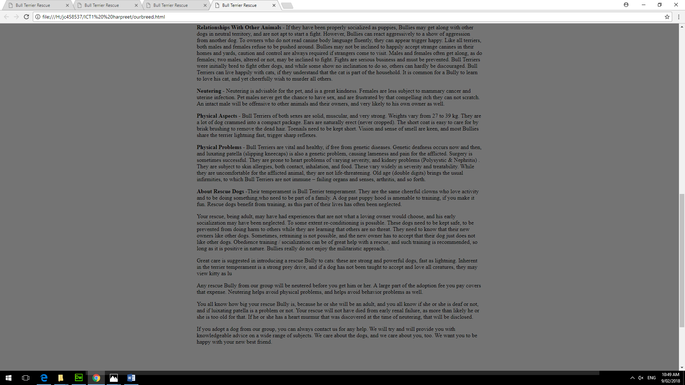

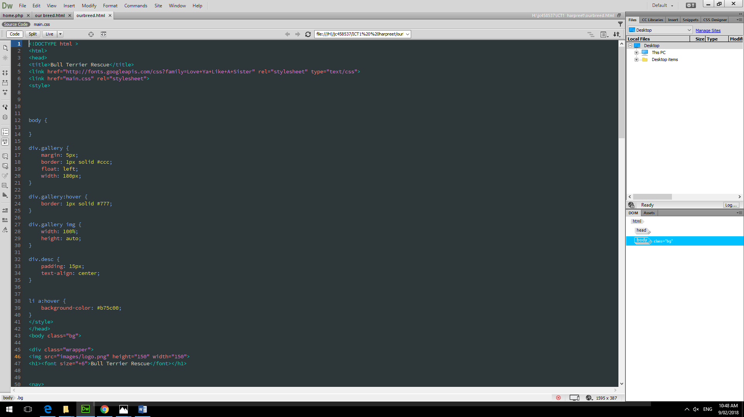

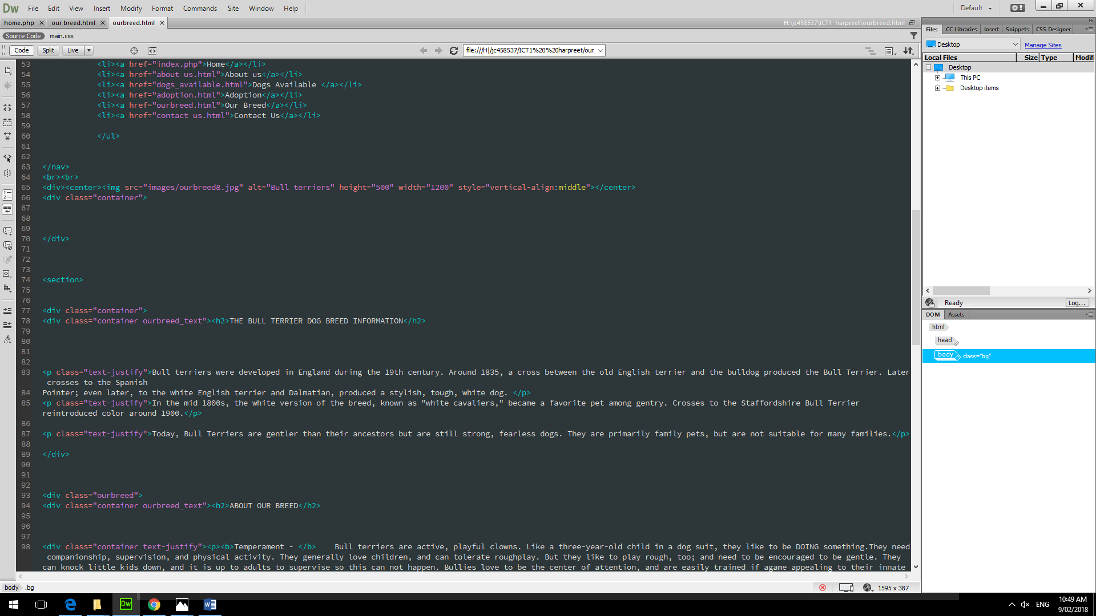

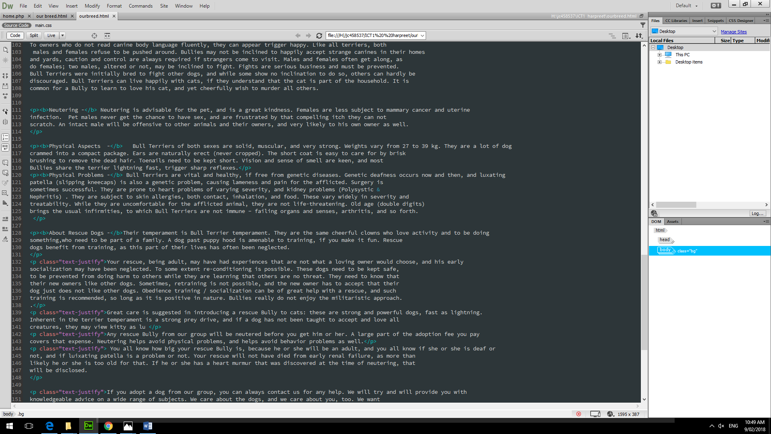

1. **Dog’s Available page**

* Dog’s available page is important for user, because it contains information about dogs status. So, user can easily find dog for adoption.
* In this page user can check availability of dogs.

**Screenshots of Dogs available page:**

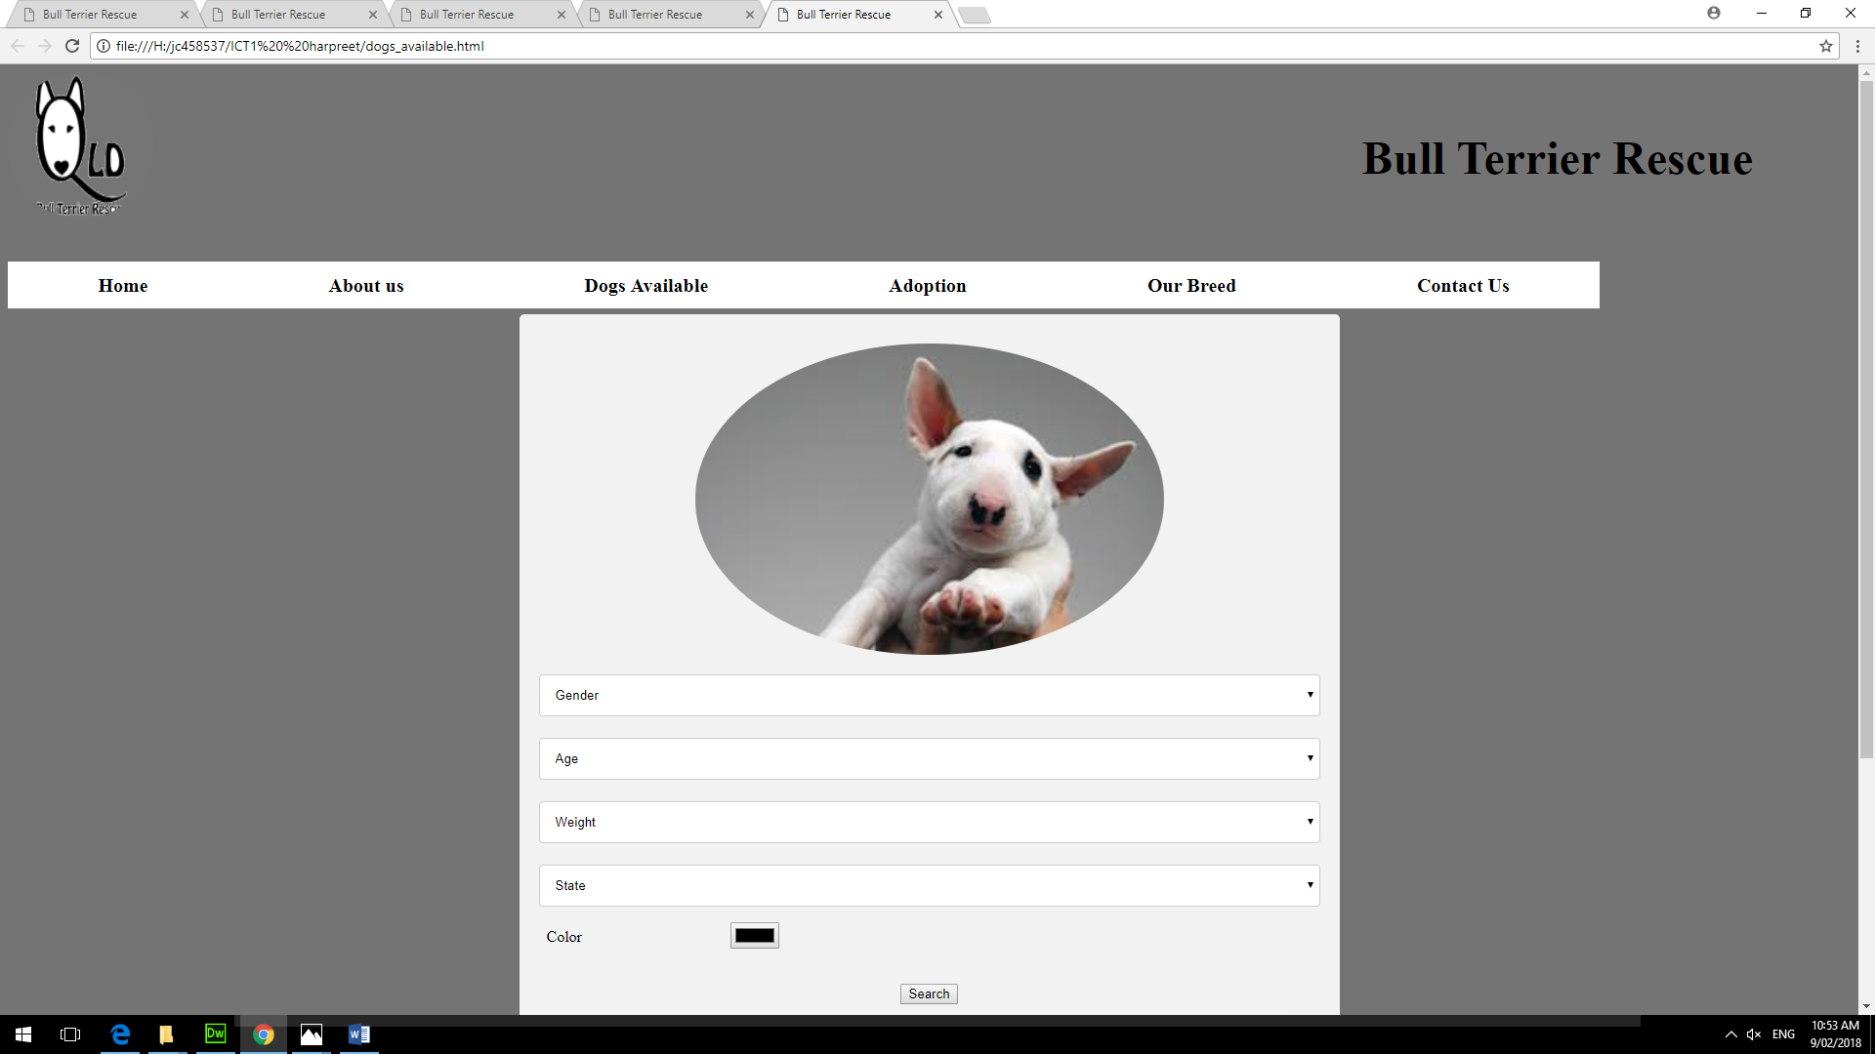

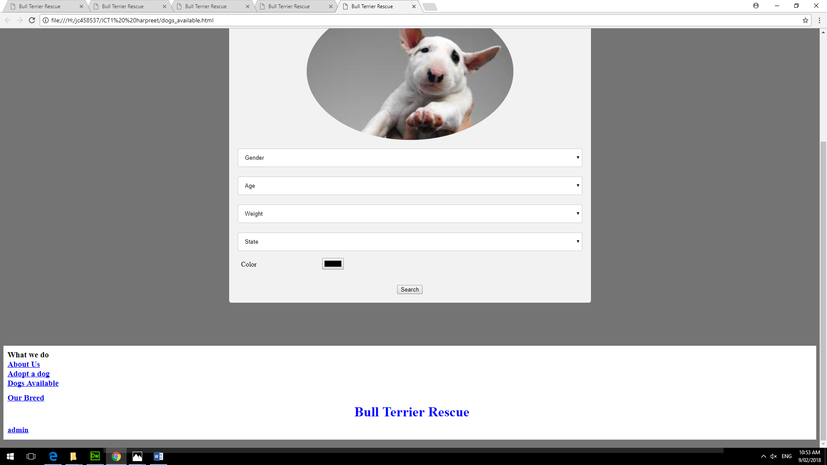

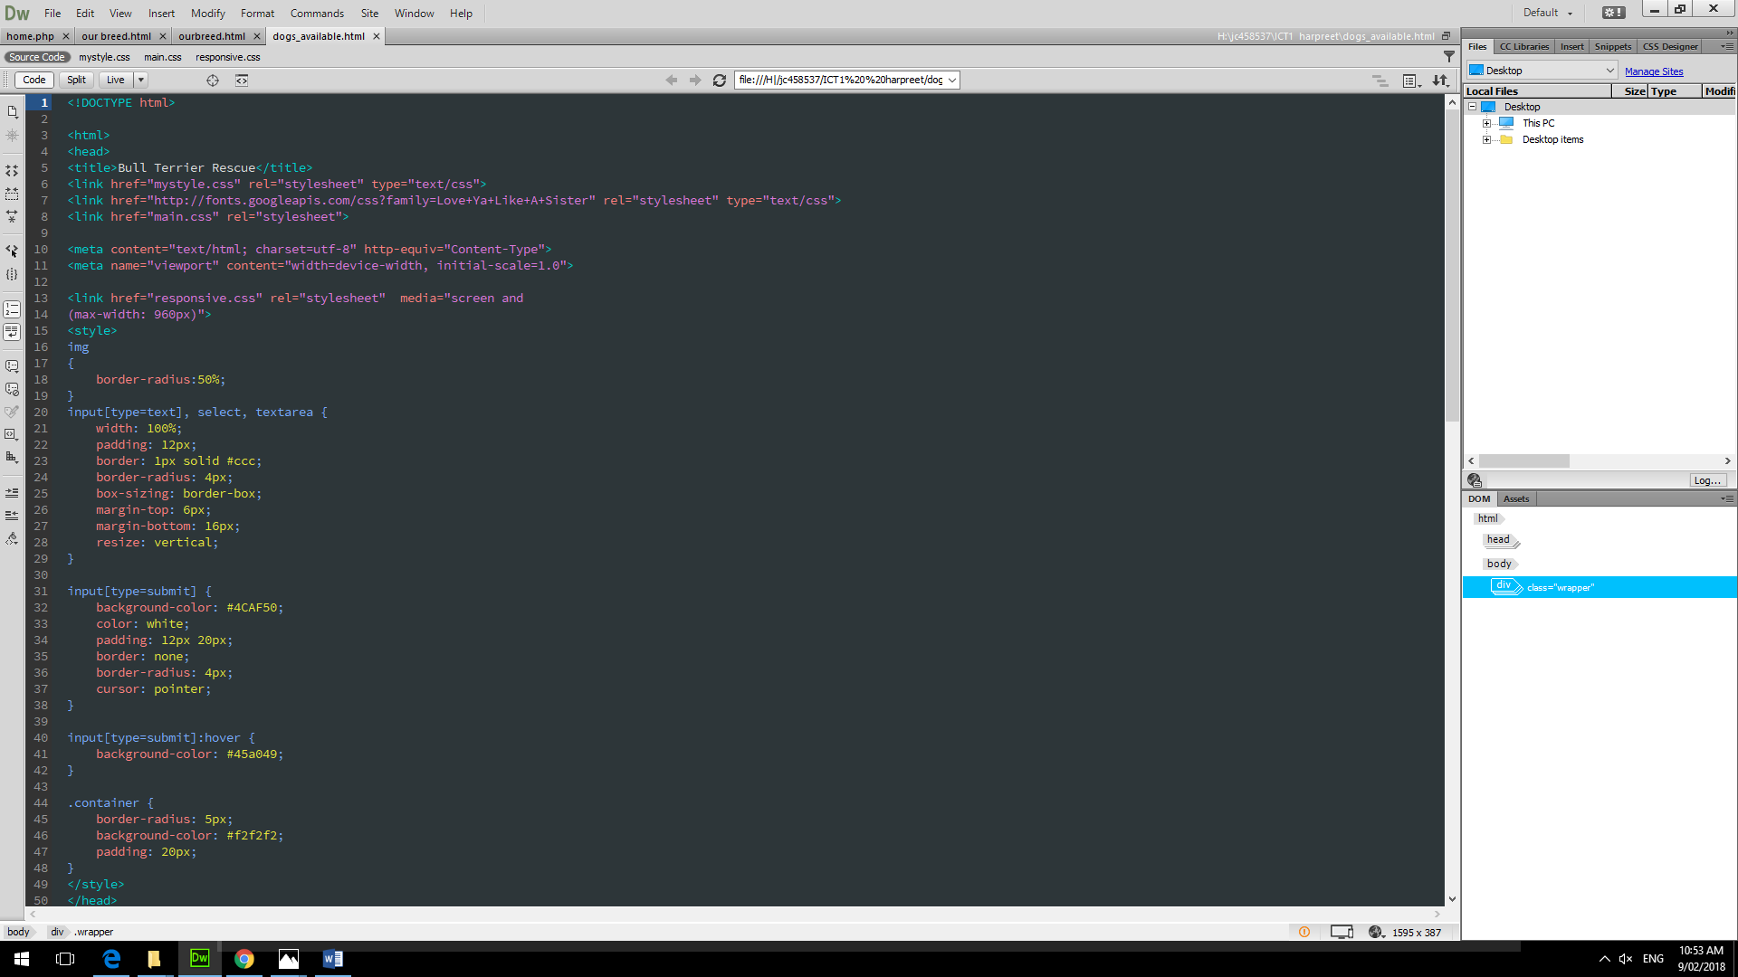

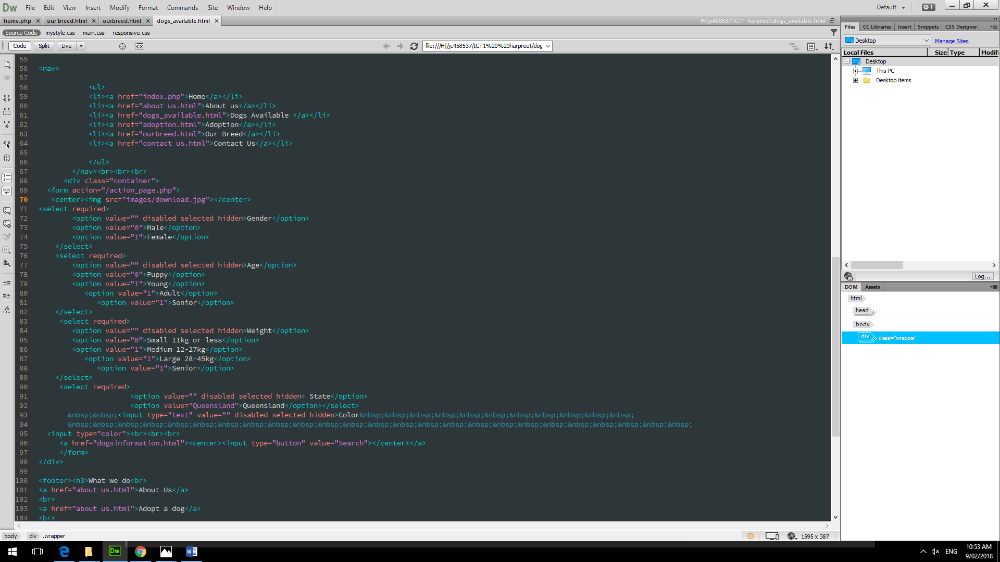

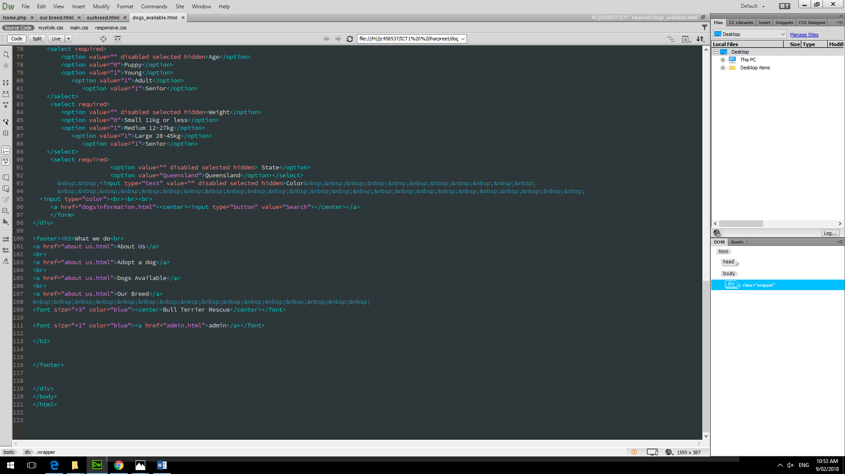

1. **Adoption**

* This page contains Adoption form. So, if user want to adopt dog they can fill out that form and adopt a dog.
* Client can get information about user such as name, address, gender, etc.

**Screenshots of Adoption page:**

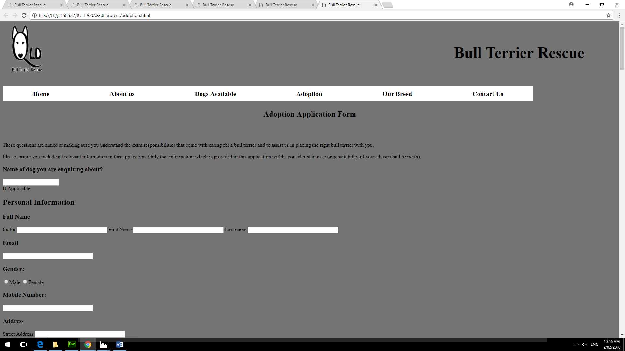

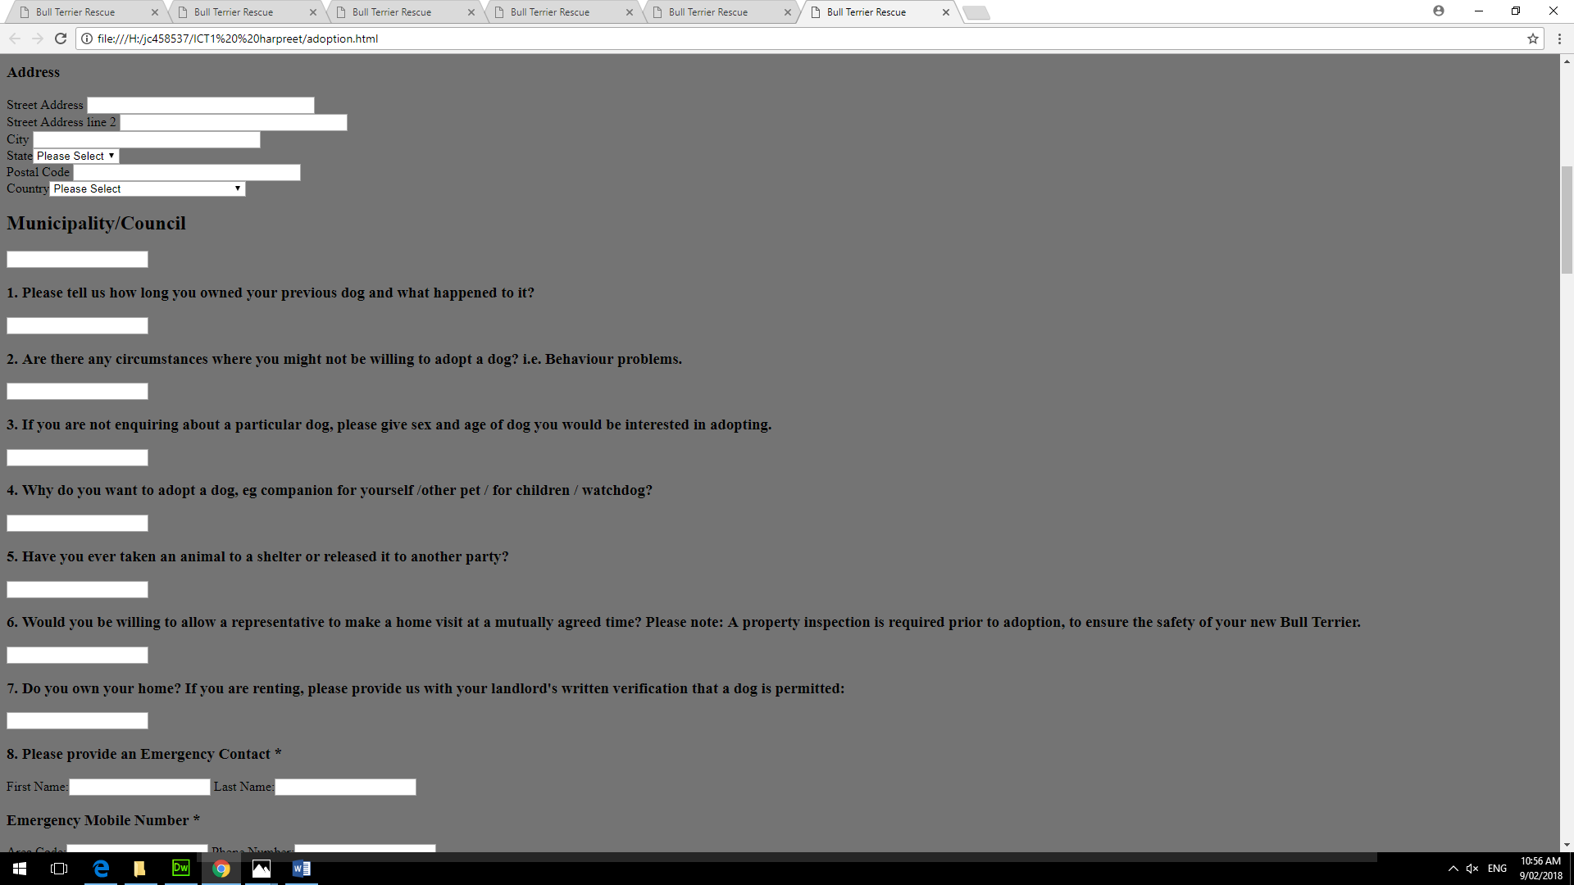

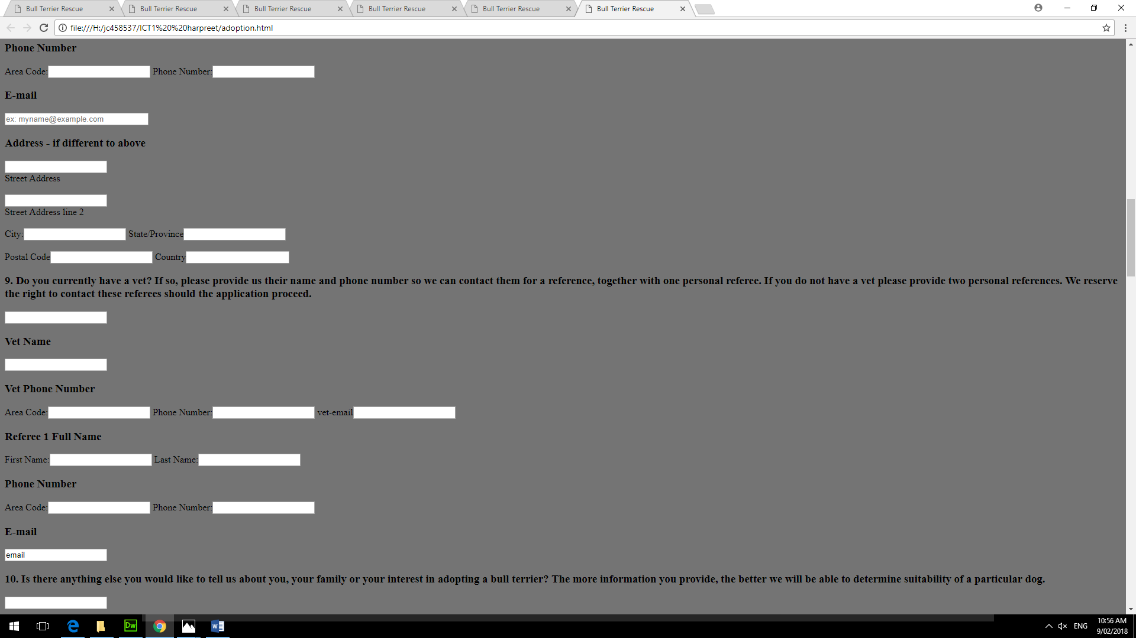

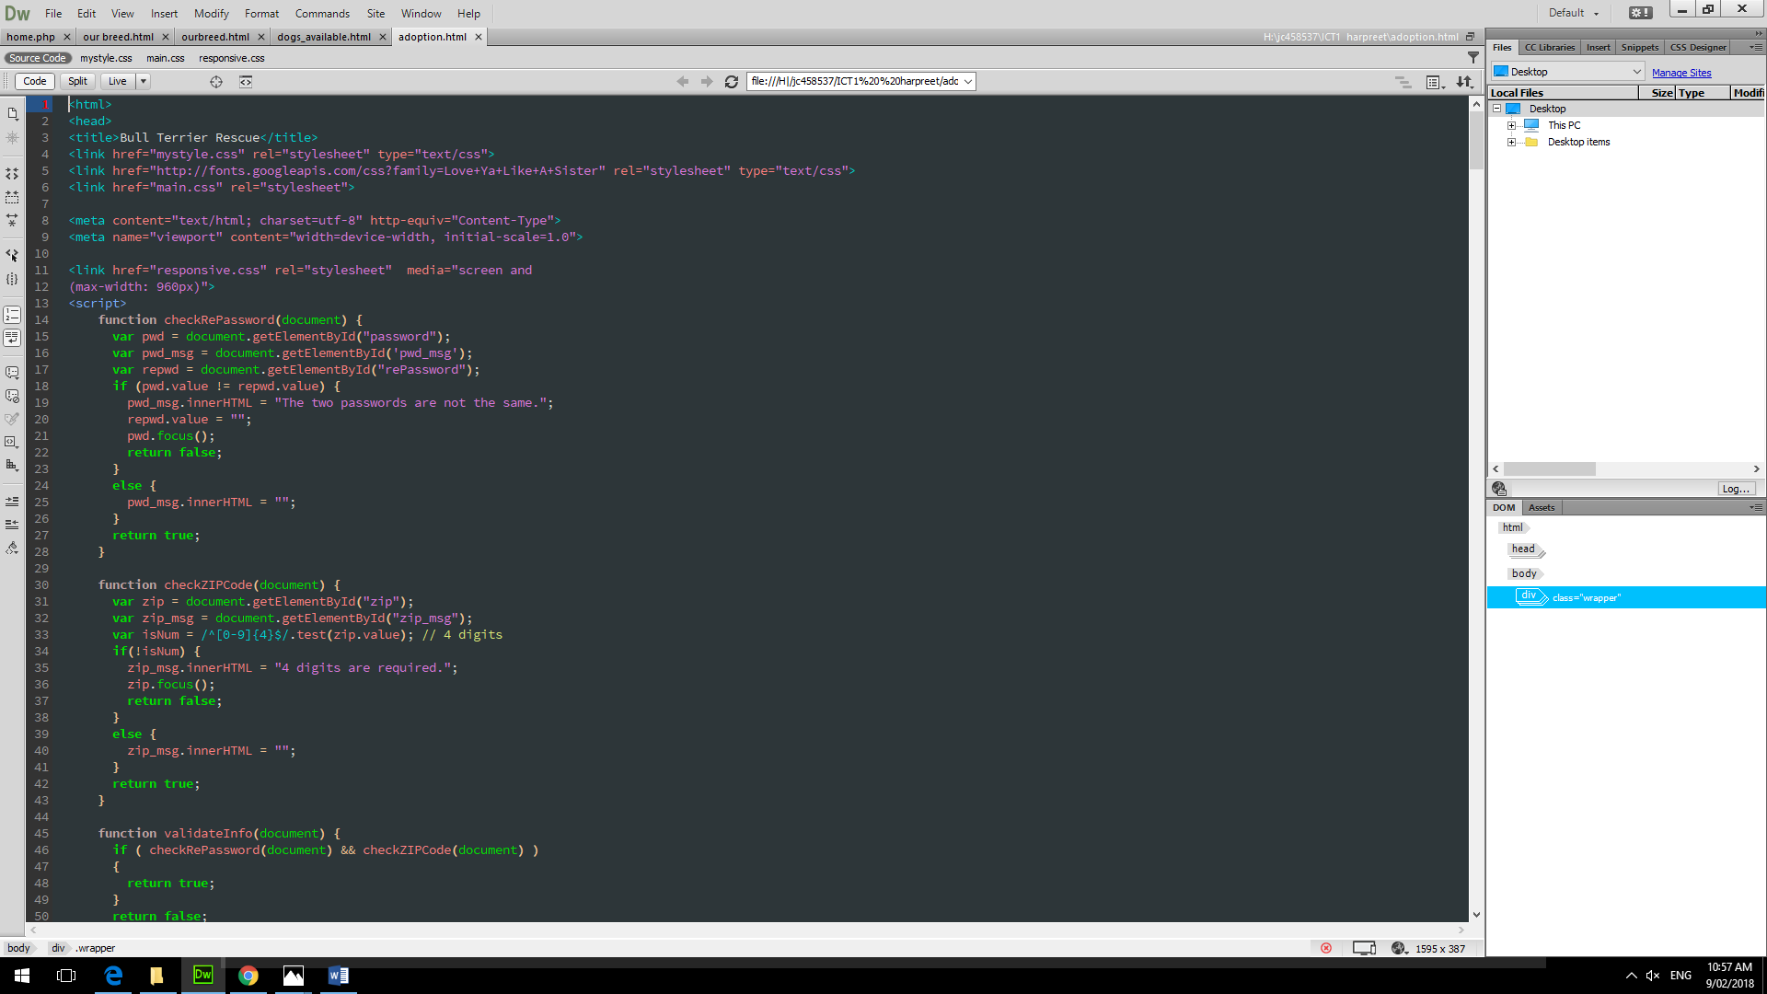

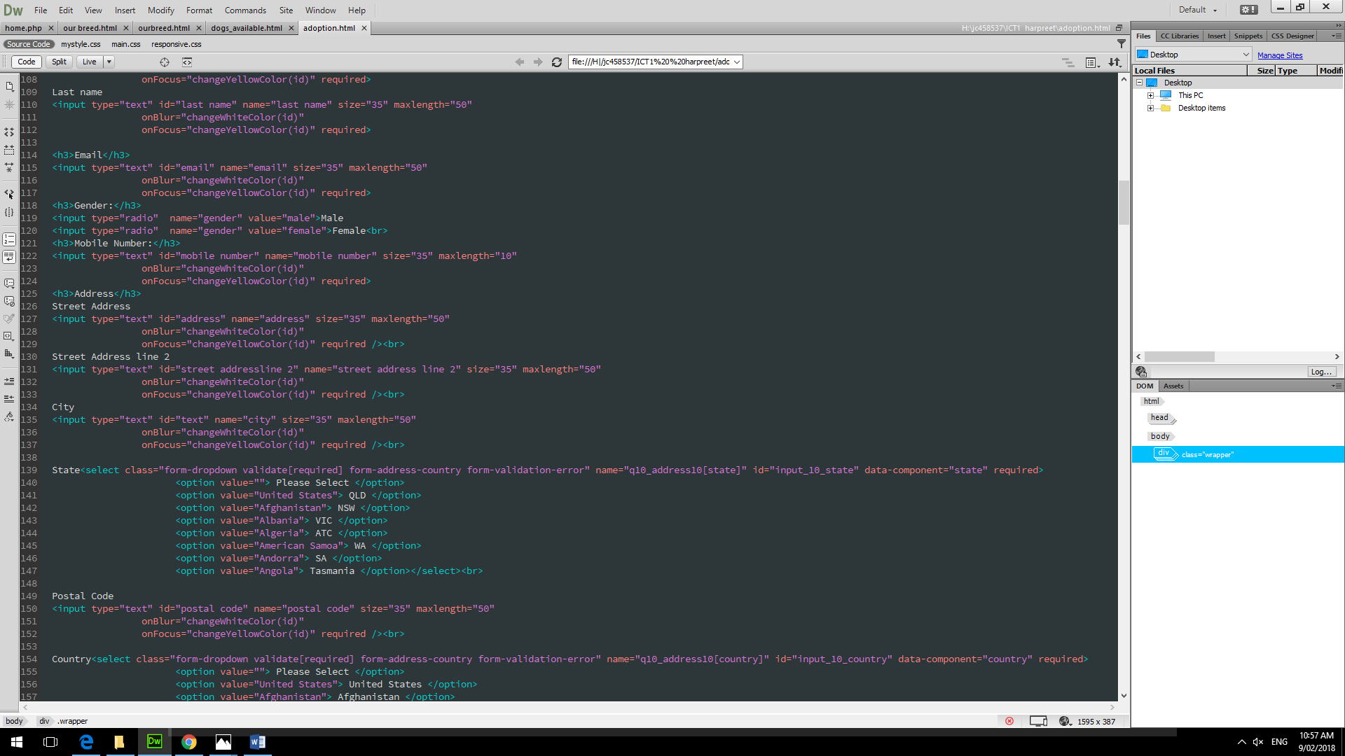

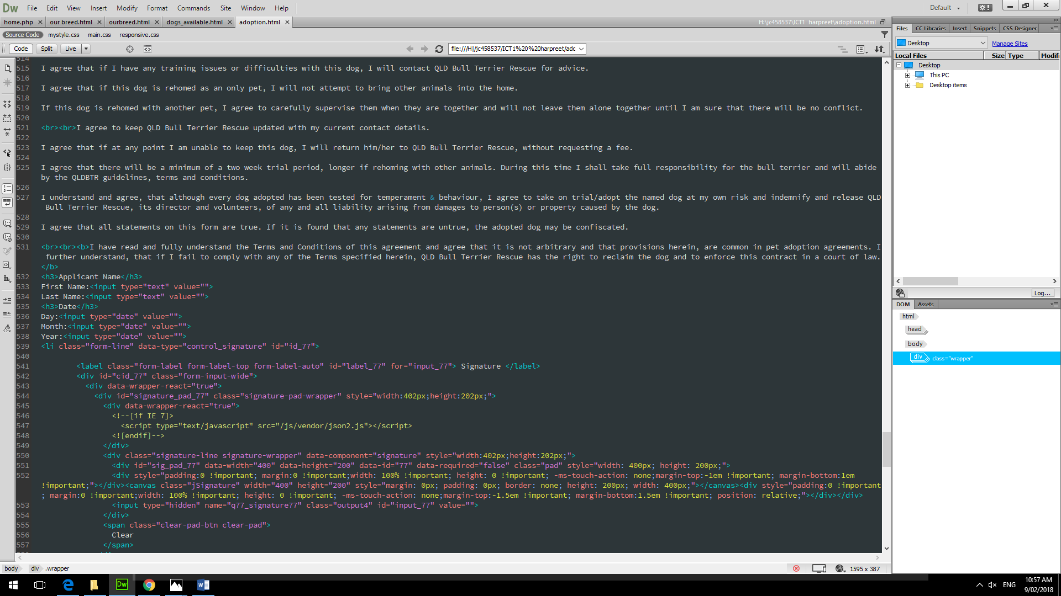

1. **Phpmyadmin (Database)**

In this project database contains few tables. So, when user fill out form with some information, after that, that information directly store in database. So client can easily find it.

**Screenshots of Phpmyadmin:**

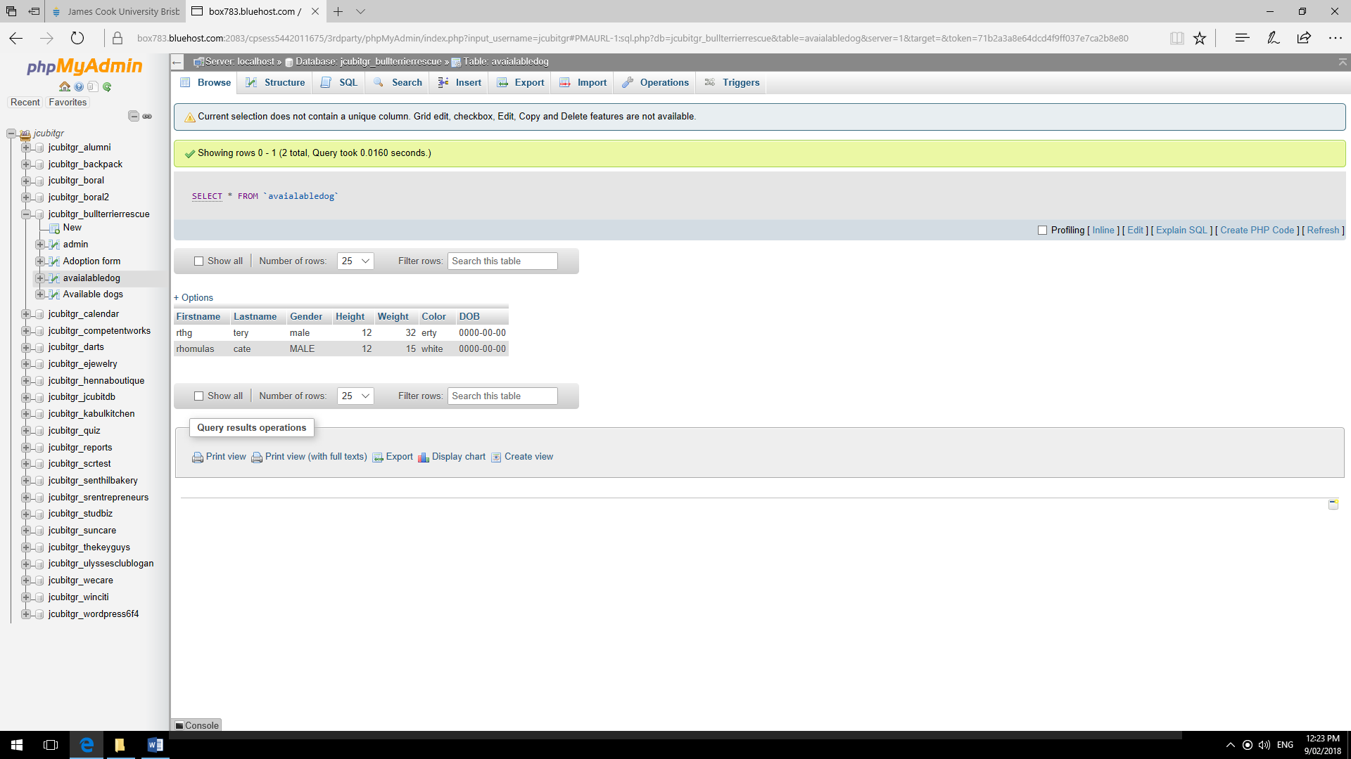

1. **Other Screenshots**
2. **Responsive.css**

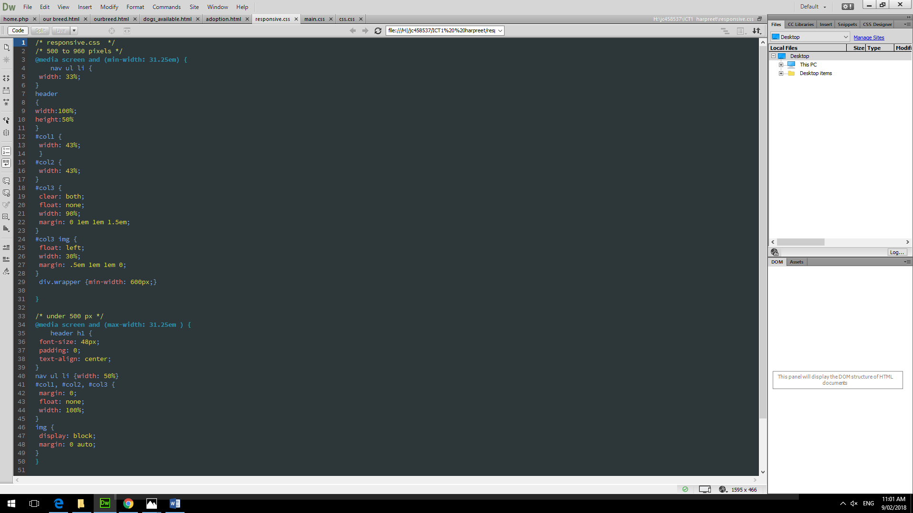

1. **Main.css**

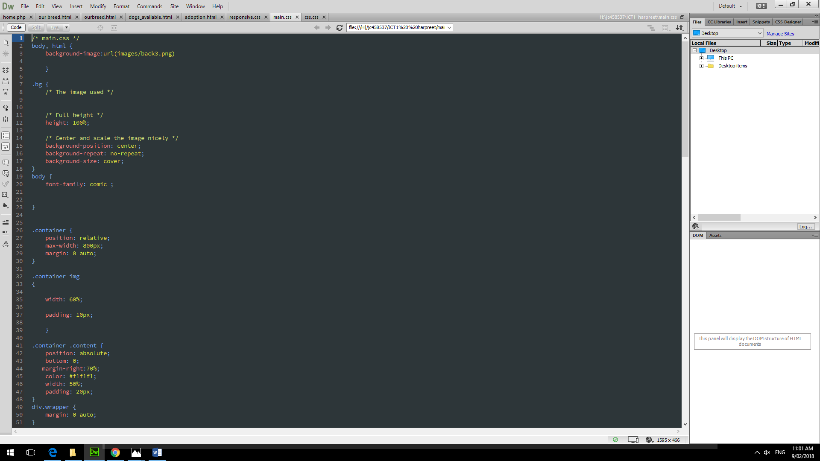

1. **Css.css**

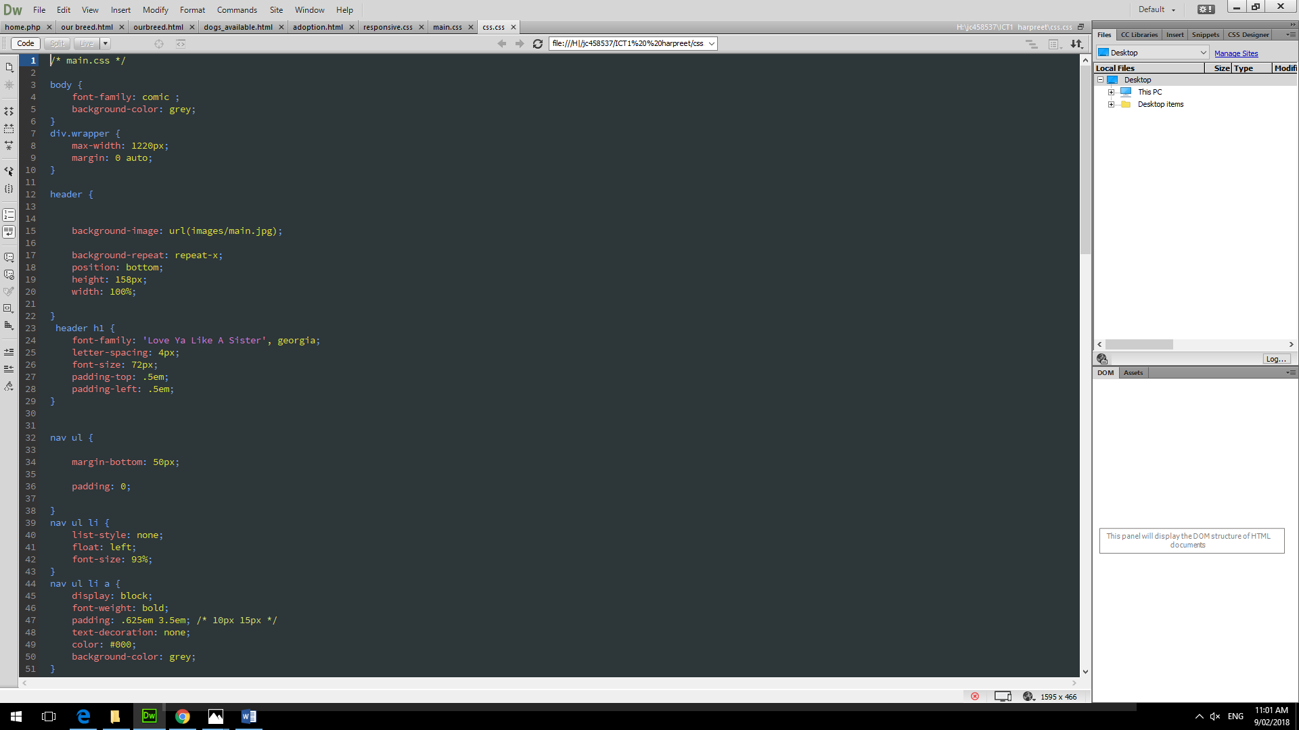

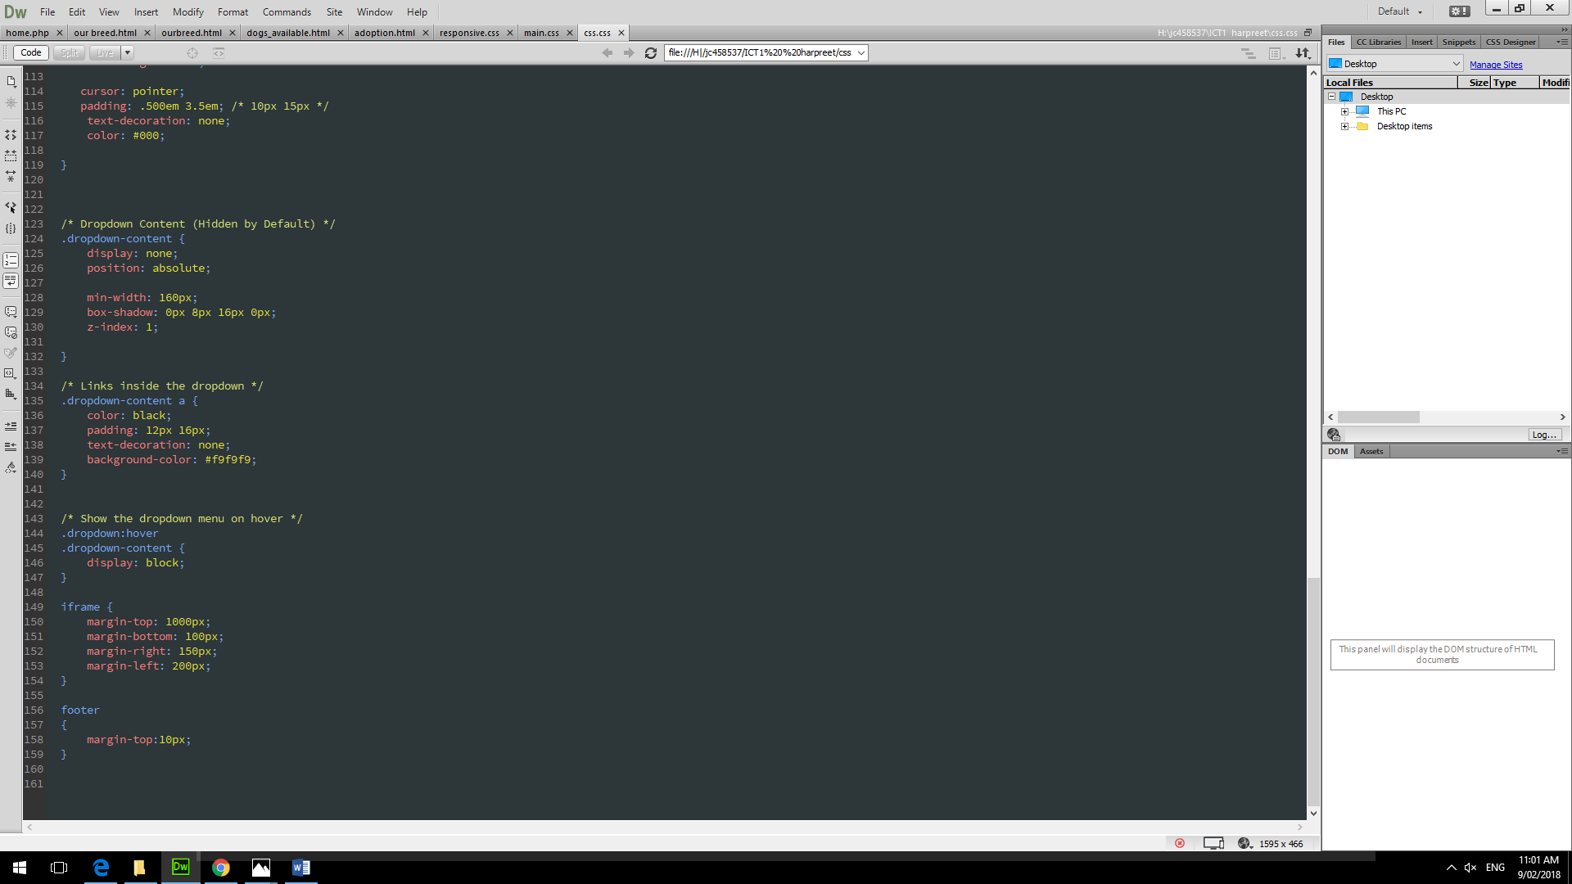

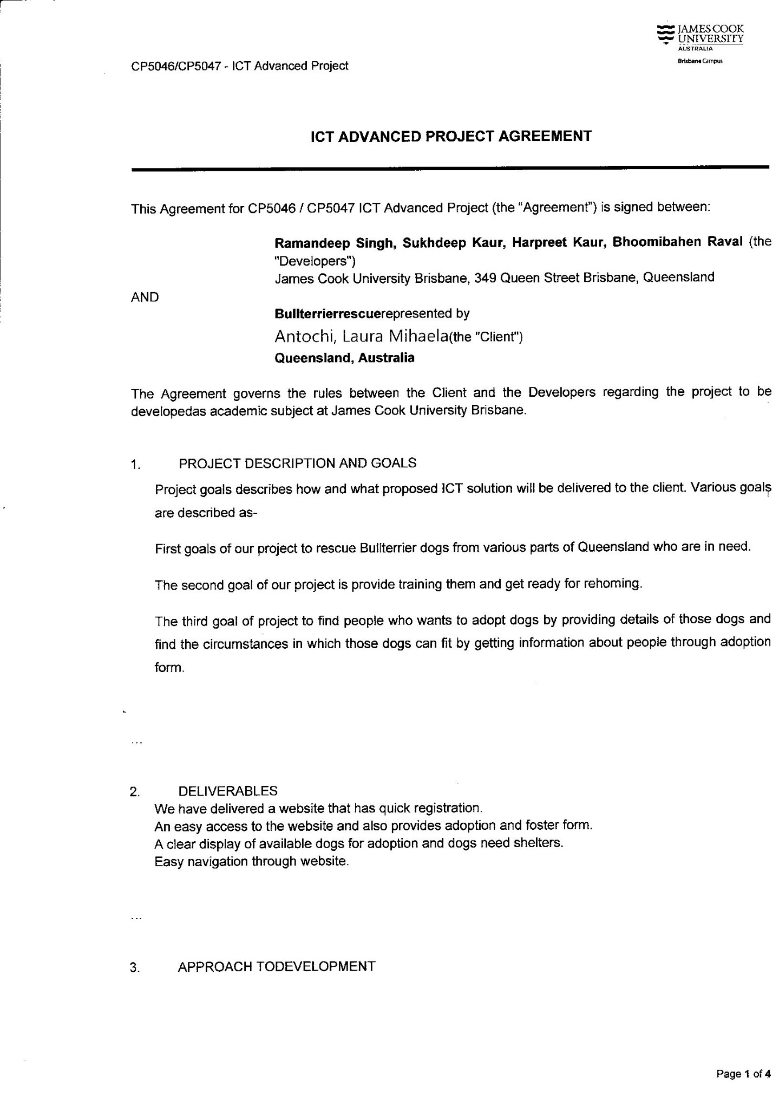**Clients Signed Agreement**

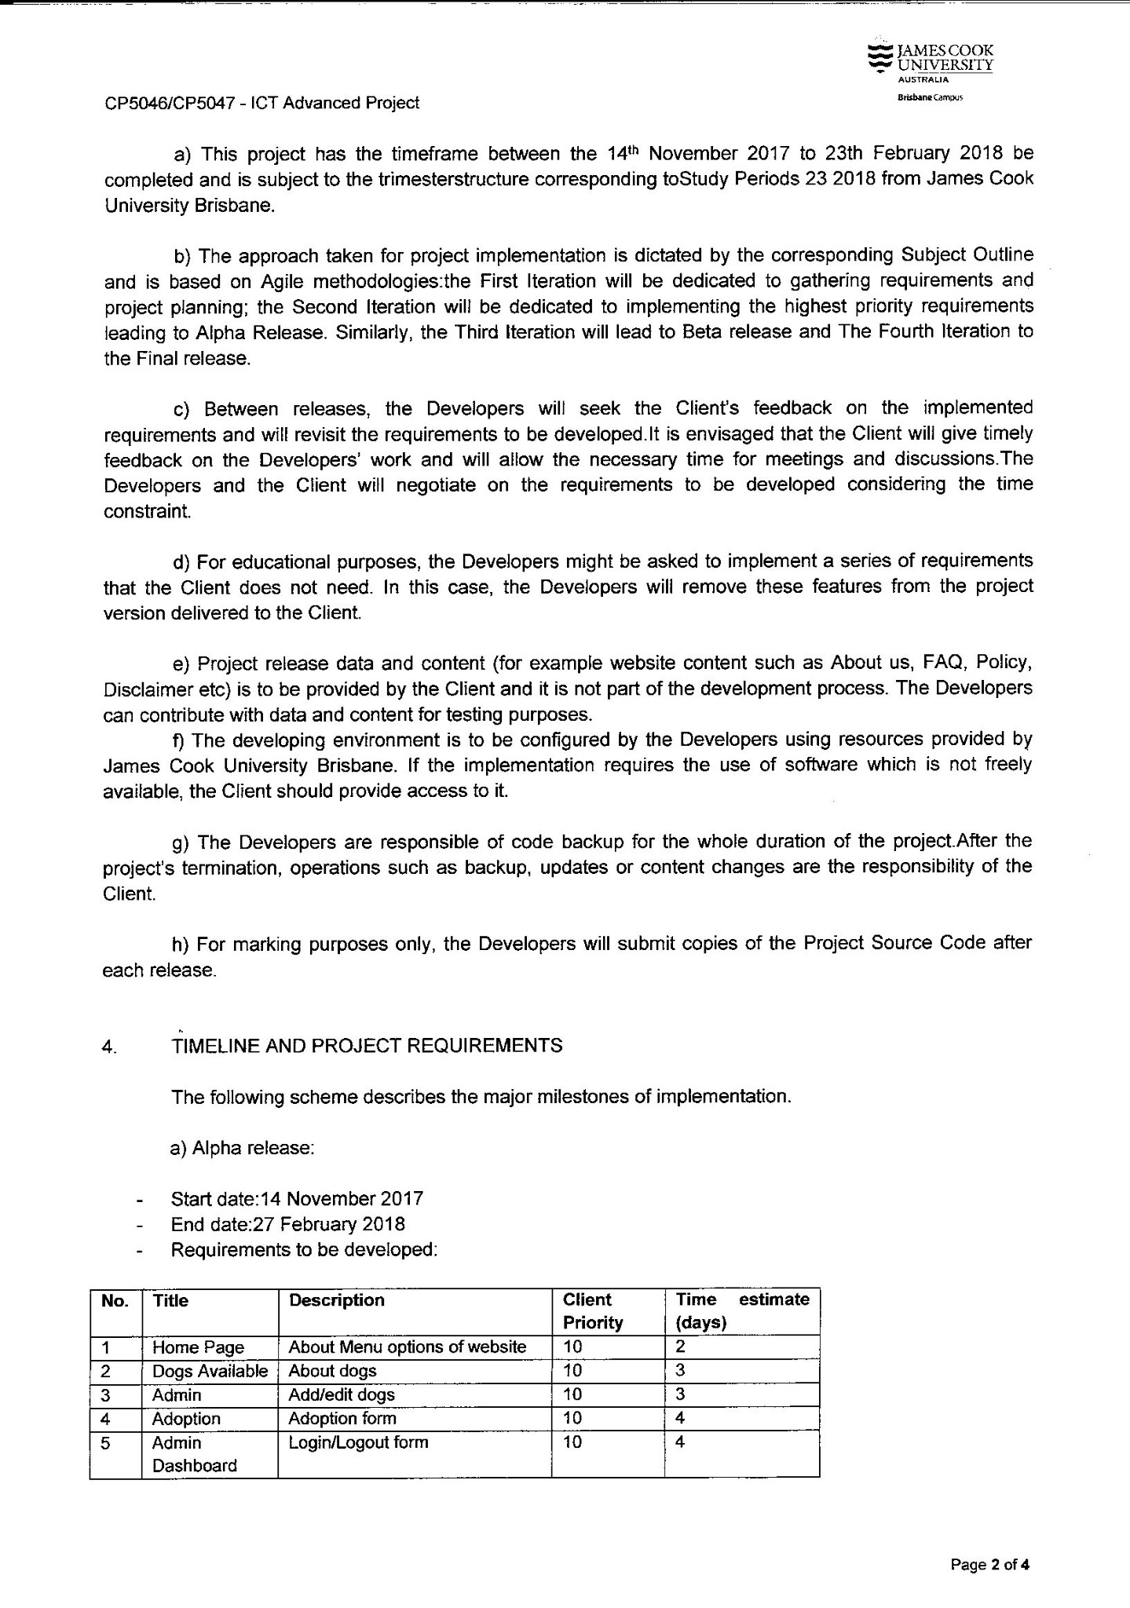

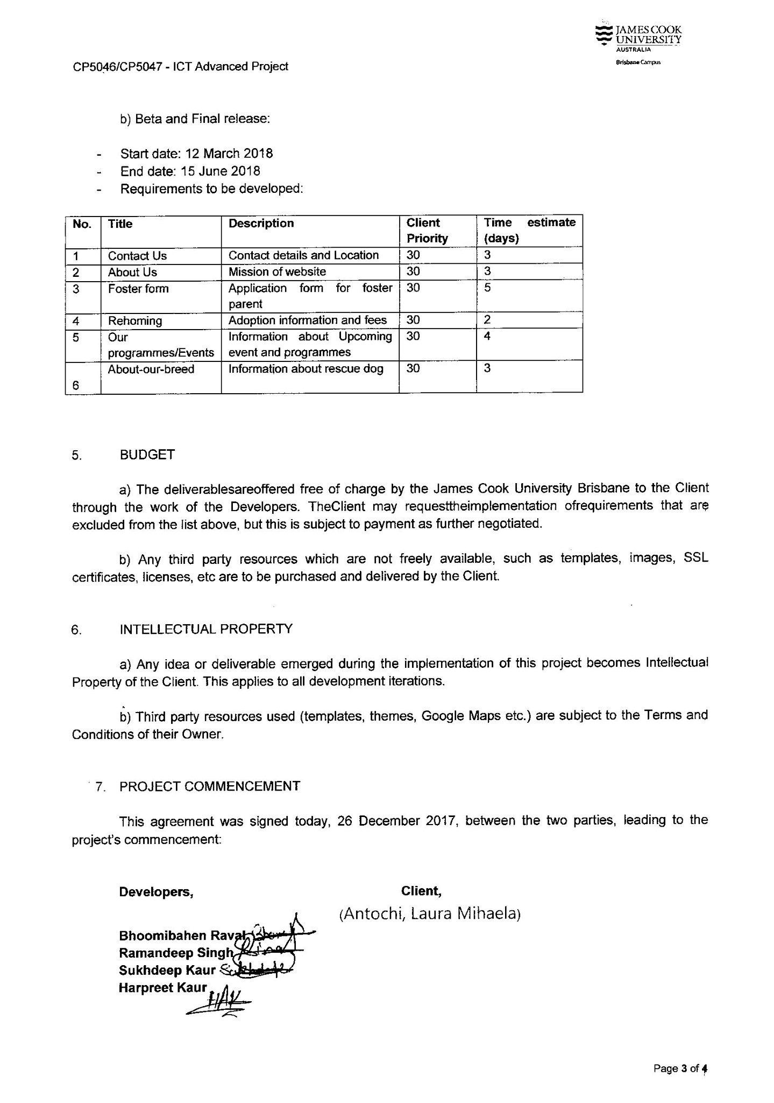

**Burn down/Velocity Graph for Alpha Release**

* We start work on 14th November 2017. First we focus on tasks for development. After that we divided tasks. And we suppose to complete it 15th of December.
* But because of some testing problems. We take bit more time to complete it.And after that we complete it at 10th February 2018.
* Our next step to complete this website is Beta release. And our beta release work start immediately after this on 12th March 2018.

**Configuration Management/Version Control**

# Technologies Used

This technologies are used for complete this project

* HTML
* CSS
* PHP
* File zilla
* Phpmyadmin
* GitHub

**Prototypes for Proposed beta release**

In beta release we will release final and complete project. The features of beta release will be as below:

* Contact us
* About Us
* Our programs/events
* Foster form/fostering questions
* Rehoming

**Title:** Contact Us

**Description:**

**As a …** Visitor

**I need …** contact details and location

**So that …** I can contact them

**Priority: 30 Time estimate: 3**

**Title:** About Us

**Description:**

**As a …** Visitor

**I need …** Information of website

**So that** … I can understand mission of the website

**Priority: 30 Time estimate: 3**

**Title:** Foster form/ fostering questions

**Description:**

**As a …**Visitor

**I need …** foster application form to fill out

**So that …** I can fill out form with my personal information and understand fostering questions

**Priority: 30 Time estimate: 5**

**Title:** Rehoming

**Description:**

**As a …** visitor

**I need …** to know about adoption fees and requirements

**So that …** I can decide to adopt dog

**Priority: 30 Time estimate: 2**

**User story cards of Beta Release**

**Title: our programmes/events**

**Description:**

**As a …Visitors**

**I need …details about upcoming event and programmes**

**So that … I can know about different programmes and events**

**Priority: 30 Time estimate:4**